1. Upload tab.

**Figure 1.** Uploading a file.

* 1. Upload a file.

To upload a file click the button *Upload file* and choose the proper file in the opened file explorer.

* 1. Choosing measurements for analysis.

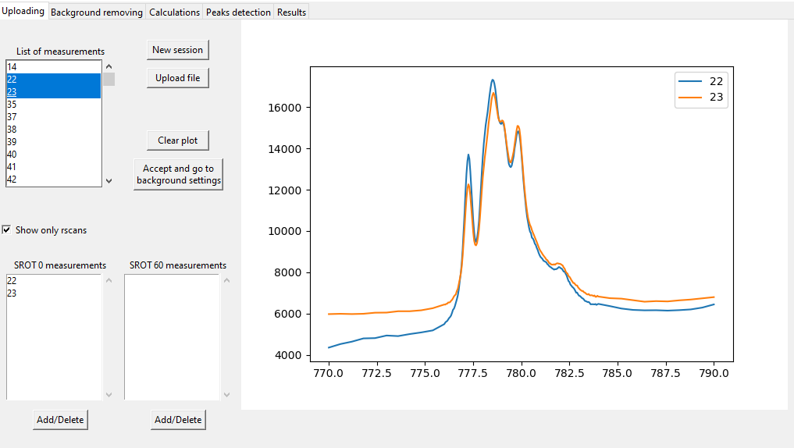

**Figure 2.** Choosing measurements for analysis.

* + 1. Show only rscans.

If you want to display only measurements as a function of energy you have to tick   
check-button *Show only rscans*.

* + 1. Spectrum preview.

To display specific spectra you need to mark the number of proper measurements in the   
*List of measurements*. To clear the canvas use the button *Clear plot*.

* + 1. Adding measurements for calculations.

To choose measurements for calculations you need to mark measurements in the  
*List of measurements* and add them to *SROT 0 measurements* or *SROT 60 measurements* using the proper *Add/Delete* button. Split into two lists allows for calculations for two grazing incident angles (SROT).

* 1. Acceptance of the choices and moving to background removal.

To accept chosen measurements for analysis click the button *Accept and go to background settings*. This will take you to *Background removing* tab.

1. *Background removing* tab.

**Figure 3.** Settings for background removal.

* 1. Background parameters.

You can change the parameters of the background curve fitting in the *Parameters* area. For fitting the program use strip background model which base on two parameters:

* strip background width (*Width*)
* strip background number of iterations (*Iterations*)
  1. Settings for background removal.
     1. No background subtraction.

If background subtraction is not necessary tick *Don’t subtract the background*check-button. The spectra will only be normalized before peaks detection and calculations.

* + 1. Using the same parameters for subtraction for all spectra.

If you want to subtract background using the same background fitting parameters to all spectra tick *Use actual parameters to all* check-button.

* + 1. Set parameters of background removal for each spectrum.

If fitting the background using different parameters values to each spectrum is necessary, you have to mark measurement, adjust the parameters and click *Subtraction* button.

**Figure 4.** Settings for background removal.

If the fitting parameters turned out to be appropriate click *Accept* button. If you want to chage set parameters click *Undo* button.

* 1. Accepting all background settings and moving to the *Calculations* tab.

To approve background removal settings for all spectra, click *Accept and go to calculations* button.

1. Calculations tab.

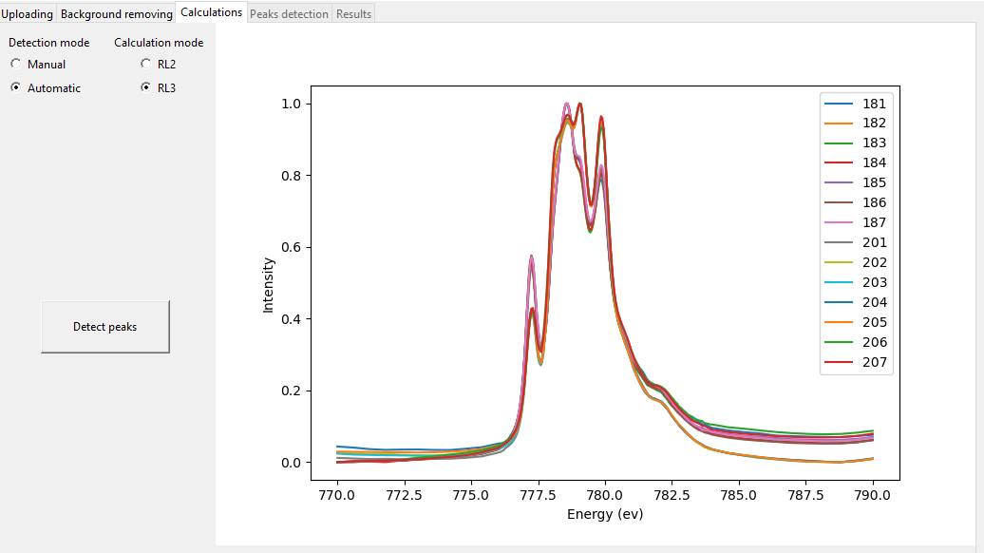

**Figure 5.** Settings for calculations.

* 1. Plot window.

In the plot window are displayed all spectra after normalization and eventual background removal.

* 1. Choosing detection mode.
     1. Automatic mode.

In automatic mode, peaks will be detected without user input for all spectra unless it is impossible to detect peaks using the program algorithm for any of the spectra.

* + 1. Manual mode.

In manual mode have to mark peaks by picking points on the plot for each of the spectra.

* 1. Choosing calculations mode.
     1. RL2 mode.

RL2 and ΔRL2 coefficients will be calculated for all spectra.

* + 1. RL3 mode.

RL3 and delta ΔRL3 coefficients will be calculated for all spectra..

* 1. Moving to the detection of the peaks.

To start detection of the peaks with choosen modes click *Detect peaks* button.